The Circus …

When the circus comes to town
With the lions, the horses and clowns
You’ll have lots of fun
Come and see with everyone
You’ll have the time of your life



The strong man lifts weights with one hand
And the jugglers turn cartwheels and land
You’ll have lots of fun
Come and see with everyone
You’ll have the time of your life

The trapeze artists fly overhea
There is a ringmaster dressed all in red
You’ll have lots of fun
Come and see with everyone
You’ll have the time of your life

See the clowns make everyone smile
As they all fall down in a pile
You’ll have lots of fun
Come and see with everyone
You’ll have the time of your life

When the circus comes to town
With the lions, the horses and clowns
You’ll have lots of fun
Come and see with everyone
You’ll have the time of your life

© British Council, 2003

I’ve Got a Robot

I've got a robot, a robot, a robot
I've got a robot in my house
I've got a robot, a robot, a robot
I've got a robot in my house
He's got fingers, he's got toes
He's got eyes and a mouth and a nose
I've got a robot, a robot, a robot
I've got a robot in my house
I've got a robot, a robot, a robot
I've got a robot in my house
He can wash and sweep and clean
To me, he's a person, not a machine

I've got a robot, a robot, a robot
I've got a robot in my house
I've got a robot, a robot, a robot
I've got a robot in my house
He can cook and mend and sew
He does my homework
My teacher doesn't know – oh!
I've got a robot, a robot, a robot
I've got a robot in my house
I've got a robot, a robot, a robot
I've got a robot in my house
I've got a robot, a robot, a robot
I've got a robot in my house
I've got a robot, a robot, a robot
I've got a robot in my house

© Sheila Margaret Ward

I Went to School

I went to school one morning,
And I walked like this,
I walked like this,
I walked like this.
I went to school one morning,
And I walked like this,
On the way to school.

I saw a rabbit,
And I jump like this,
I jump like this,
I jump like this,
I saw a rabbit,
And I jump like this,
On the way to school.

I saw a rabbit,
And Ijump like this,
Ijump like this
Ijump like this
I saw a rabbit,
And Ijump like this,
On the way to school.

I saw a teacher,
And I ran like this,
I ran like this,
I ran like this,
I saw a teacher,
And I ran like this,
On the way to school.

Dreams

What did you do last night
In your dreams in your dreams?
What did you do last night in Your dreams?

Did you sing like a bird?
Did you swim like a fish?
Did you shine like a star
In your dreams?

Did you fly like a kite?
Did you fight like a dragon?
Did you ride like a knight
In your dreams?

Why?

Why do flowers have petals?
Why do birds have wings?
Why can’t somebode tell me
The reason for these things?

Why do leaves grow on the trees?
Why do they turn brown?
Why do clouds stay in the sky?
Why don’t they fall down?

Why do we hate rubbish
And wasting energy?
Because this lovely planet
Earth
Belongs to you and me.

He’s ever so clever

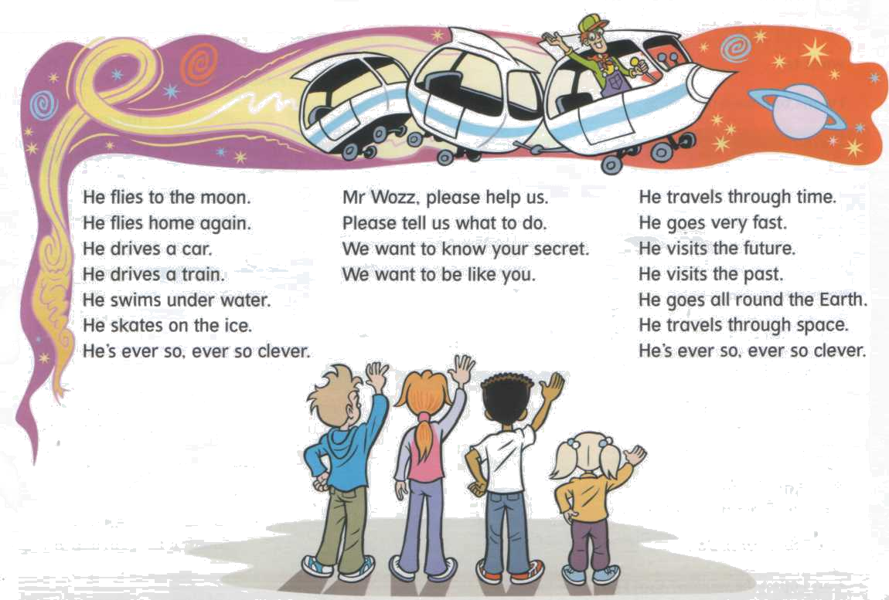

He fleis to the moon,
He fleis home again.
He drives a car,
He drives a train.
He swims under water,
He skates on the ice.
He is ever so,ever so,clever

He travels through time,
He goes very fast.
He visits the future,
He visits the past.
He goes all around the Earth,
He travels through space.
He is ever so,ever so,clever

Mr.Wozz, please help us,
Please tell us what to do.
We want to know your secret,
We want to be like you.

Birthday Presents

I’d like to have a mountain bike.
I’d like to have a boat.
I’d like a pair of rollerblades
And a brand new winter coat.

I’d like to have a racing car.
I’d love a camera too.
I’d like a silver scooter
And a new pair of shoes.

But it really doesn’t matter
If I don’t have jewels or rings.
Friends are my treasure –
Life’s most important things.

Dreaming

Climb the highest мountain
Fly to any star
Walk the darkest forest
Where the dragons are.

Swim the longest river
With jungls on each banks
Find the wreck of a pirate ship
That hit a rock and sank.

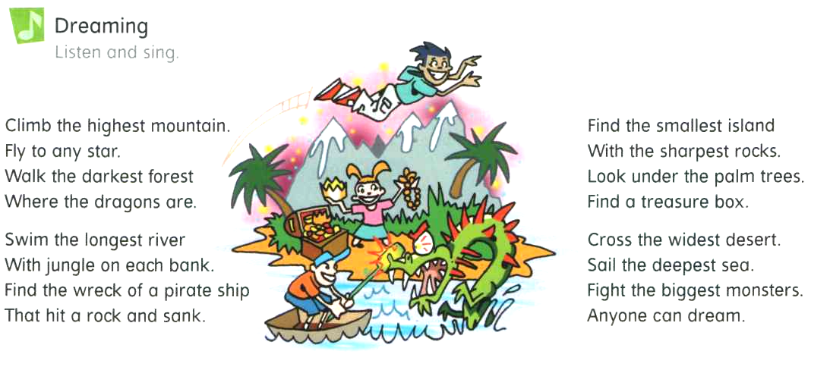

Find the smallest island
With the sharpest rocks.
Look under the palm tree
Find a treasure box.

Cross the widest desert
Sail the deepest sea.
Fight the biggest monsters.
Anyone can dream.

Friends

My friend Annie
Is taller then me.
My friend Pete
Has got bigger feet.

Bigger or smaller
Taller oa shorter
Thinner or fatter
It doesn’t matter.

My friend Rose
Has got a shorter nose.
My griend Peg
Has got longer legs.

Bigger or smaller
Taller oa shorter
Thinner or fatter
It doesn’t matter.

I’m Lost

I’m lost. I’m lost. I’m lost again.
Please, help me find the way.

Turn left at the park,
Then turn right.
Go straight on,
Then left at the light.

I’m lost. I’m lost. I’m lost again.
Please, help me find the way.

Go straight on,
Turn right.at the school.
Turn left at the bank,
Go past the school.

I’m lost. I’m lost. I’m lost again.
Please, help me find the way.

Go straight on,
Cross the road and then…
….Oh! No! I’m lost again.

I’m lost. I’m lost. I’m lost again.
Please, help me find the way.

I Like coffee

I like coffee,
I like tea,
I like swimming in the sea

I like apples,
I like pears,
I like sliding down the stairs

I like butter,
I like bread,
I like reading books in bed.

I like biscuits,
I like cake,
I like fishing in the lake.

add the song

chocolate/cheese
climbing up tall trees
yellow/red
standing on my head

The Ballad of Harry Holster

Harry Hoster was a baddie
He robbed trains so did his daddy,
They had a dog. Its name was Lou.
Their dog was a daddie too.
One day Harry robbed a train,
Harry won’t do that again.
I can tell you why because…
On that train was Mr. Wozz.
Mr. Wozz jumped from his seat,
He caught Harry by the feet
Ben and Sally, Rick and Meg,
They caught Harry by the leg.
Harry Hoster’s story ends
In jail.But what about our friends?
That afternoon at half past four,
They went through a big white door.

Can You Count In English

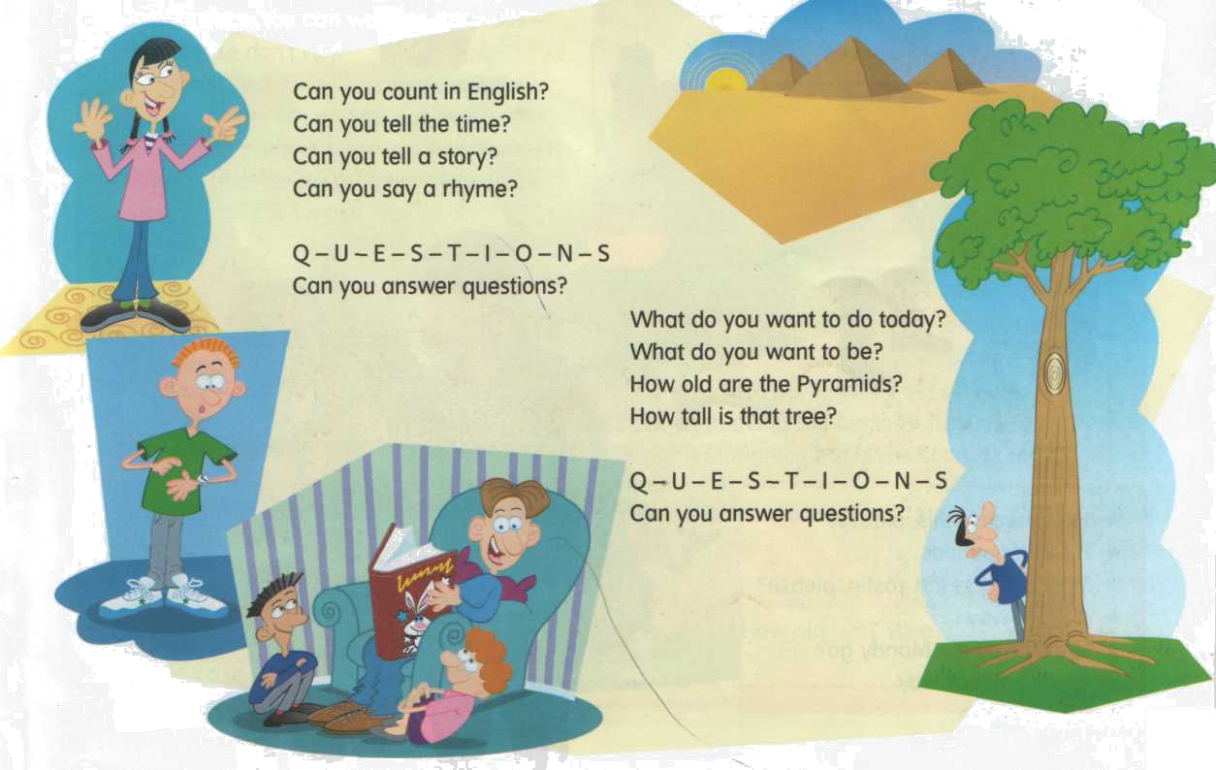

Can you count in Enhlish?
Can you tell the time?
Can you tell the story?
Can you say a rhyme?

Q U E S T I O N
Can you answer question?

What do you want to do today?
What do you want to be?
How old are the Pyramids?
How tall is that tree?

Q U E S T I O N
Can you answer question?

I'm driving

I'm driving in a car
I'm driving in a car
I'm driving in a car
I'm driving in a car

Over the mountains
Through the trees
Travel the world
And the seven seas

I'm sailing on a ship
I'm sailing on a ship
I'm sailing on a ship
I'm sailing on a ship

I'm sailing on a ship
I'm driving in a car and
Over the mountains
Through the trees
Travel the world
And the seven seas

I'm travelling on a train
I'm travelling on a train
I'm travelling on a train
I'm travelling on a train

I'm travelling on a train
I'm sailing on a ship
I'm driving in a car and
Over the mountains
Through the trees
Travel the world
And the seven seas

I'm riding on a horse
I'm riding on a horse
I'm riding on a horse
I'm riding on a horse

I'm riding on a horse
I'm travelling on a train
I'm sailing on a ship
I'm driving in a car and
Over the mountains
Through the trees
Travel the world
And the seven seas

Over the mountains
Through the trees
Travel the world
And the seven seas

© David Holmes

My Computer Mouse

I’ve got a mouse
I play with every day
He runs across the mat
And his tail is long and grey
He doesn’t like cheese
He likes playing games
He’s not afraid of cats
He hasn’t got a name

He’s my computer mouse
He’s my double click, single click
Run around the mat computer mouse
Left click, right click, double click. OK!

I’ve got a keyboard
I use it every day
He’s got a lot of letters
We’ve got a lot to say
We write a lot of emails
‘Cause we’ve got lots of friends
When we’ve written them
I ask my mouse to click on send

He’s my computer mouse
He’s my double click, single click
Run around the mat computer mouse
Left click, right click, double click. OK!

He clicks on my screen
I turn my speakers on
He opens up the programmes
On my CD Rom
Then we turn up the sound
And we turn off the lights
And we play lots of games
And chat with friends all night.

The Zoo Song

Walking with my familly
Going to the zoo
Looking at the animals
Is fun for me and you

Monday,Tuesday,
Wednesday,Thursday,
Friday,Saturday,too,
Every day is a fun day,
Fun for you and me.

Looking at the penguins,
Watching what they do,
Taking lots of hpotos,
Is fun for me and you.

Monday,Tuesday,
Wednesday,Thursday,
Friday,Saturday,too,
Every day is a fun day,
Fun for you and me.

We’re All Going to the Zoo

We’re all going to the zoo tomorrow.
Zoo tomorrow, zoo tomorrow.
We’re all going to the zoo tomorrow
And we can stay all day.

We’re all going to the zoo tomorrow.
How about you,you,you.
You can come too,too,too.
We’re all going to the zoo zoo,zoo.

See the elephant’s trunk swinging.
Great big ears and long trunk swinging.
Eating up peanuts with his long trunk swinging.
And we can stay all day.

See the monkeys scratch,
scratch scratching.
Swinging in the trees and scratch,scratch scratching.
Hanging by their long tails scratch,scratch scratching.
And we can stay all day.

Happy Holidays

We went away on holiday
To stay with Uncle Jim.
The sea was cold, the waves were big.
We couldn’t have a swim.

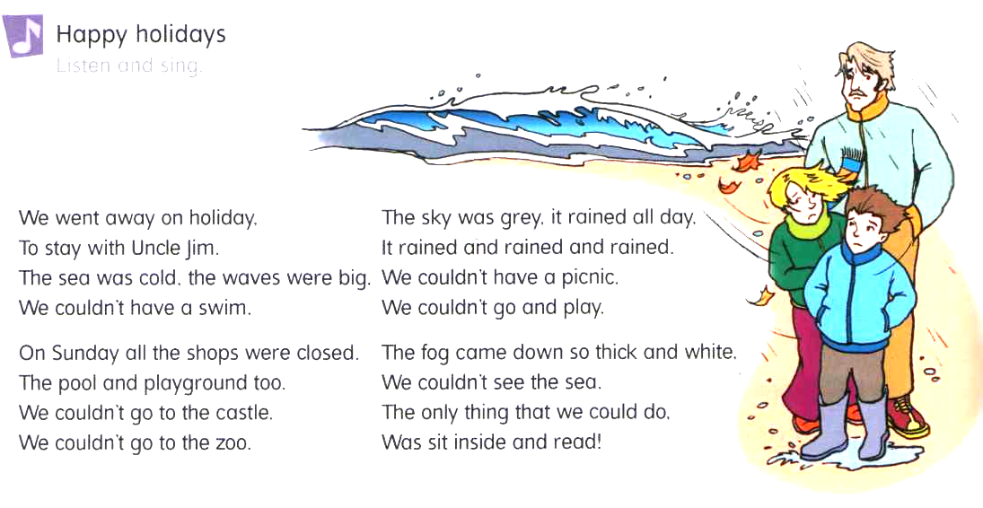

On Sunday all the shops were closed.
The pool and playground too.
We couldn’t go to the castle.
We couldn’t go to the zoo.

The sky was grey, it rained all day.
It rained it rained and rained.
We couldn’t have a picnic.
We couldn’t go and play.

The fog came down so thick and white.
We couldn’t see the sea.
The only thing we could do,
To sit inside and read.

Bike Ride

Along the road,
Out of town,
Up the hill
Freewheel down.

Across the bridge,
Through the wood,
The wind in my hair
Feels so good.

Past the castle,
Around the lake.
And home for tea.
(Hope there’s some cake)

Have You Ever

Have you ever heard a child
Laughing out loud?
Have you ever seen the sun
Come out behind the cloud?

Have you ever found a ladybird
And held it in your hand?
Have you ever taken off your shoes
And walked in the sand?

Have you ever seen snow
Falling from the sky?
The world is full of lovely things
That money just can’t buy.

Can a …

Can a flea climb a tree?
Yes he can, yes he can
Can a flea climb a tree?
Yes he can, can, can

(Repeat verse)

He can eat and drink
He can hear and see
But can he do the cancan like me?

Can a mouse build a house?
No he can’t, no he can’t
Can a mouse build a house?
No he can’t, can’t, can’t

(Repeat verse)

He can eat and drink
He can hear and see
But can he do the cancan like me?

Can the cat catch a cat
Yes he can, yes he can
Can the cat catch a cat
Yes he can, can, can

(Repeat verse)

He can eat and drink
He can hear and see
But can he do the cancan like me?

Can a pig dance a jig?
No he can’t, no he can’t
Can a pig dance a jig?
No he can’t, can’t, can’t

(Repeat verse)

He can eat and drink
He can hear and see
But can he do the cancan like me?
Can a snake eat a cake?
Yes he can, yes he can
Can a snake eat a cake?
Yes he can, can, can

(Repeat verse)

He can eat and drink
He can hear and see
But can he do the cancan like me?

© David Holmes, 2002

